**Lab 5-Linux Argument Parsing scripts**

**Q1 Write a script to print the sum of digits of number. i.e. 546=5+4+6=15. Print number in reverse**

**order using for loop. i.e. 10-1.**

**CODE:**

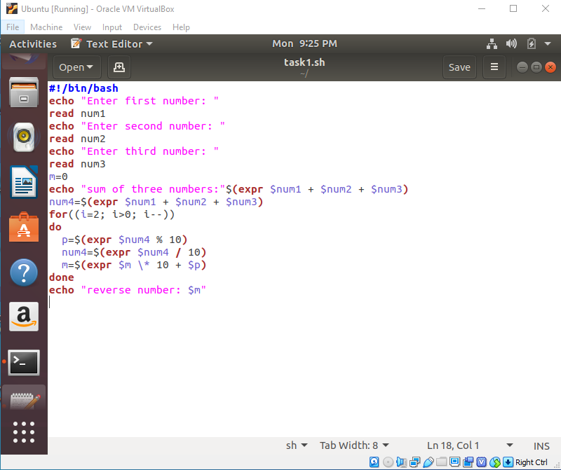

**OUTPUT:**

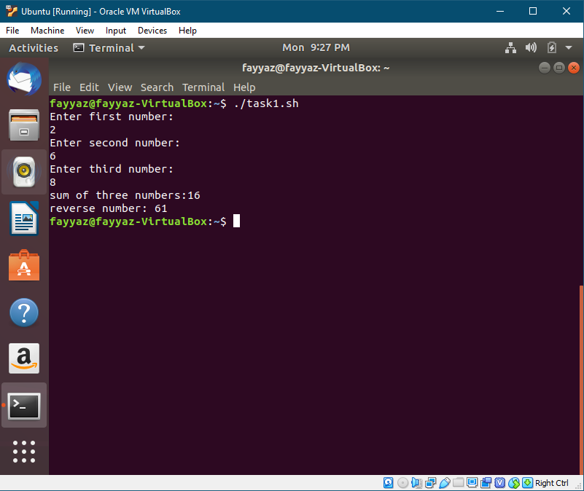

**Q2 Write a shell script to take a number input from user and then print the table for the given**

**number. i.e. if n=5 then 5*1=5.**

**CODE:**

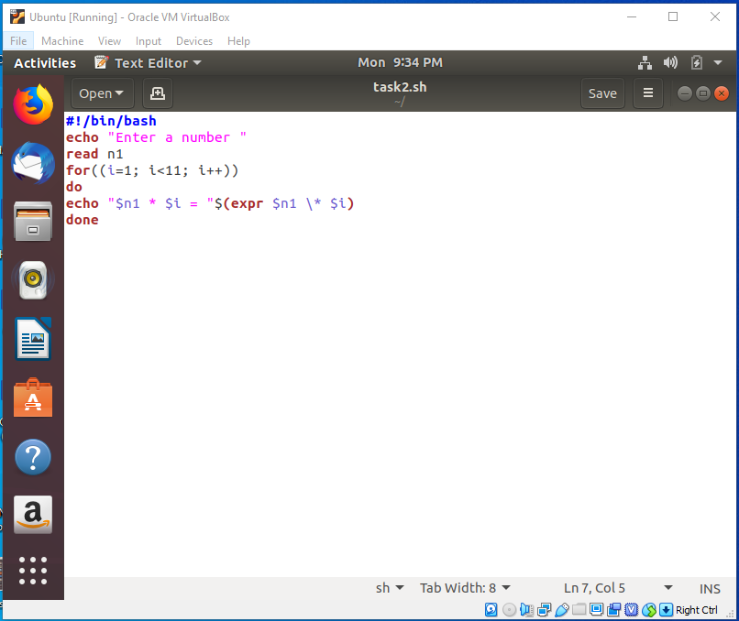

**OUTPUT:**

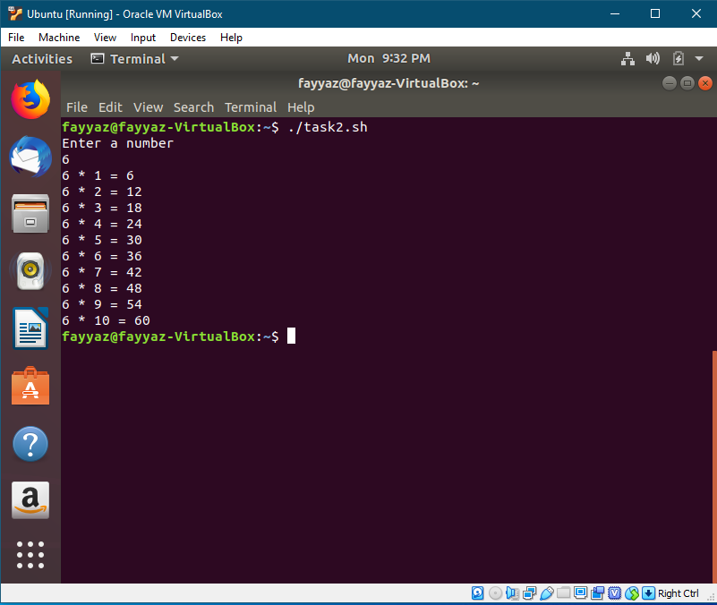

**Q3 Write scripts /commands / syntax that take input and check the number is positive or negative.**

**CODE:**

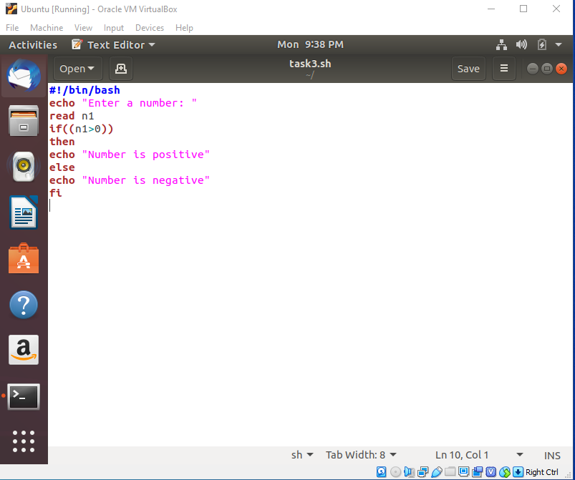

**OUTPUT:**

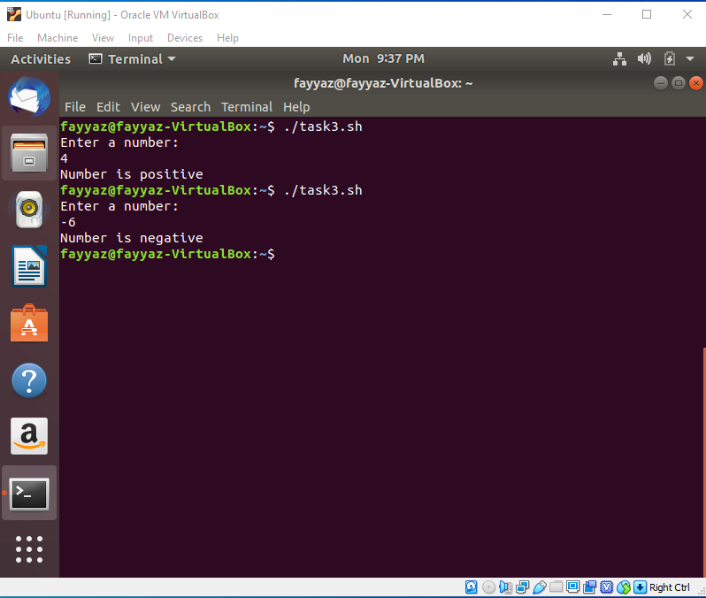

**Q4 Write scripts /commands / syntax that print a message 10 times.**

**CODE:**

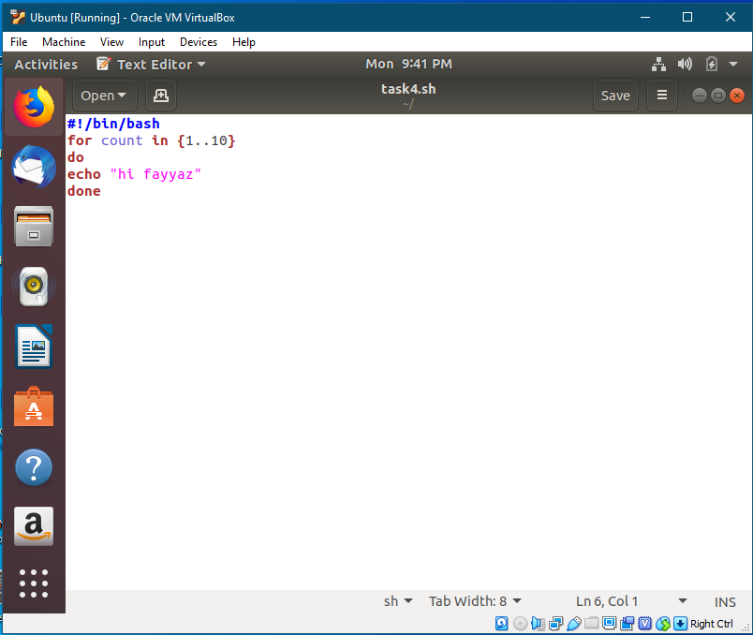

**OUTPUT:**

